**Refinements in the paper**

**(Automatic whole cell organelle segmentation in volumetric electron microscopy,** [**https://www.biorxiv.org/content/10.1101/2020.11.14.382143v1.full#F7**](https://www.biorxiv.org/content/10.1101/2020.11.14.382143v1.full#F7) **)**

**Disclaimer: information here is taken from the relevant source stated in the paragraph.**

**Brief intro to morphological operations (full credit to**

<https://towardsdatascience.com/understanding-morphological-image-processing-and-its-operations-7bcf1ed11756> ) **:**

Morphology operations are a set of image processing operations that extract image components like region shape, boundaries, etc. To perform morphological operation, a **structuring element** is applied on the input image to yield an output image pf the same size in a manner similar to applying a kernel. Such operation can be performed as a pre-process or post-process image segmentation in order to remove imperfections or improve the segmentation itself.

What is structural element? It is a kernel or a small-sized "filter" that is used to traverse an image. The structural element can be in any shape (according to its purpose) and is applied at all possible locations in the image, and it is compared with the connected pixels.

See some important definitions demonstrated in the figure below:

**Fit:** When all the pixels in the structuring element cover the pixels of the object, we call it Fit.

**Hit**: When at least one of the pixels in the structuring element cover the pixels of the object, we call it Hit.

**Miss:** When no pixel in the structuring element cover the pixels of the object, we call it miss.

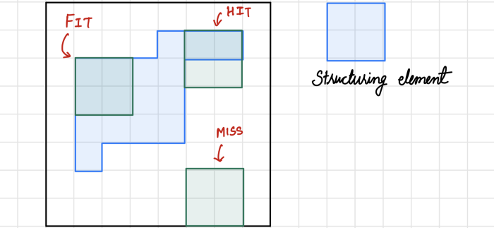

The most important operations are:

Erosion: This operation shrinks the image pixels and removes pixels on object boundaries. The structuring element is applied over the image object to perform an erosion operation, as shown in the figure below. The output pixel values are calculated using the following equation.

Pixel (output) = 1 {if **FIT**}, Pixel (output) = 0 {otherwise}

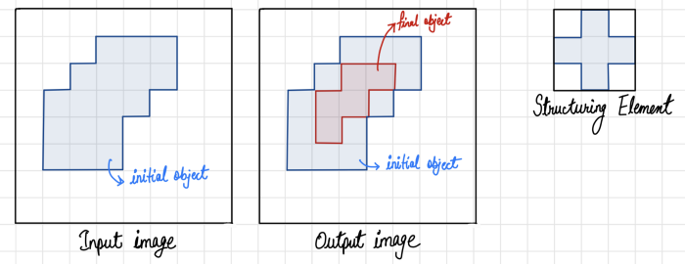

This operation splits joined objects and removes extrusions.

Dilation: as a contrast to erosion, this operation expands the image pixels and can adds pixels on object boundaries. It is applied in a similar way to erosion, but the output is calculated using the following equation:

Pixel (output) = 1 {if **HIT**}, Pixel (output) = 0 {otherwise}.

See demonstration:

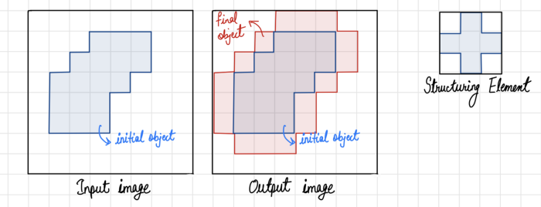

This operation merges over-segmented objects (repair breaks) and repair intrusions.

There are more morphological operations that are composed mainly by using these two. More two common operations:

1. Closing: performing dilation-> erosion.
2. Opening: performing erosion->dilation.

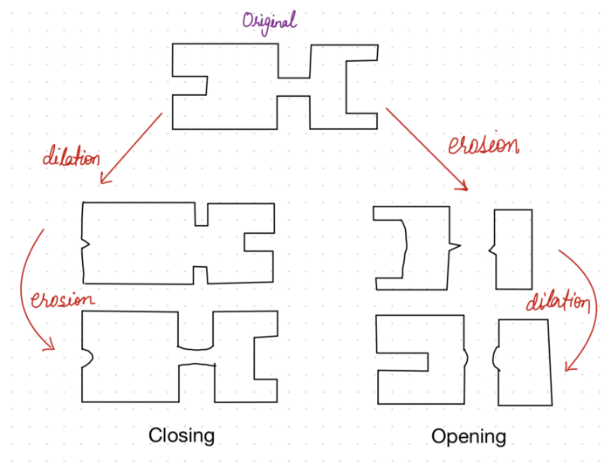

“Smoothing: A Gaussian filter (σ = 12 nm) was applied to the initial predictions to smooth them out and reduce noise.” (Heinrich et al. n.d.)

**Gaussian Smoothing:**

Smoothing is a convolution operator, that is used to `blur' images in order to remove noise via kernel. Gaussian smoothing kernel blurs an image, in a similar fashion to the mean filter. The degree of smoothing is determined by the standard deviation of the Gaussian. The Gaussian outputs a `weighted average' of each pixel's neighborhood, with the average weighted more towards the value of the central pixels (see example). This is in contrast to the mean filter's uniformly weighted average. Because of this, a Gaussian smoothing provides gentler smoothing and preserves edges better than a similarly sized mean filter.

See example of Gaussian convolution kernel that approximates a Gaussian with a s.d. of 1.0

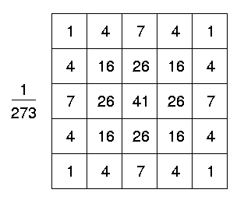

For more details please see: <https://homepages.inf.ed.ac.uk/rbf/HIPR2/gsmooth.htm>

Before reading the next explanations I highly recommend seeing this video:

Distance transform:

<https://www.youtube.com/watch?v=oxWfLTQoC5A&t=5s>

“Connected components: Except for ribosomes and microtubules (discussed later), all organelle predictions were thresholded at a predicted distance of 0 nm, above which voxels were

considered part of an organelle; this corresponds to signed tanh distance transform ≥ 0. Connected component analysis of these organelle voxels was then performed to group the voxels into individual organelles with distinct IDs.” (Heinrich et al. n.d.)

**Connected components:**

In 2D images Connected components labeling, we scan an image and groups its pixels into components based on pixel connectivity (connected component have similar pixel intensity values and are in some way connected with each other). Once all groups have been determined, each pixel is labeled. (<https://homepages.inf.ed.ac.uk/rbf/HIPR2/label.htm#1> )

Voxel connectivity of connected-component labeling in this paper were performed based on the predicted distance of signed distance function. In such function, the threshold determines the 3D boundary of the organelles as it represented in zeroes. (it was extremely weird they call it tanh as I couldn’t find anything similar to "tanh distance function", however during research I found that probably it is because of the word signed aka +/-). The interior voxels of the organelle are signed with distance>0 whereas the exterior voxels is signed with distance<0. each voxel is assigned with values that tells whether it belongs to a certain component (organelle) or not.

*Size Filtering*: “Often, a minimum size filter was applied to the connected components in order to eliminate small false positives. The size of the filter was conservative and based on the expected organelle size.” (Heinrich et al. n.d.)

**Size filtering:**

It is also called as stated above minimum filtering. When a minimum filter is applied to a digital image it picks up the minimum value of the neighborhoods pixel window and assigns it to the current pixel. A pixel with the minimum value is the darkest among the pixels present in the pixel window. The dark values present in an image are enhanced by the minimum filter.

Minimum filter can be considered as a dilation filter. When minimum filter is applied the object boundaries present in an image are **extended.** The minimum filter is one of the morphological filters. The other morphological filters include maximum filter and the median filter. The minimum filter removes any positive outlier noise present in a digital image, aka the purpose of the refinements **“eliminate small false positives”.**

Source: <https://pythontic.com/image-processing/pillow/minimum%20filter>

Custom Filtering: “When size filtering alone was insufficient, an expert user inspects the results and selects which individual objects should be removed.” (Heinrich et al. n.d.)

**Custom filtering:**

No further details are available since it is not an automated or an image processing procedure.

**Hole filling:**

Hole-filling: “Additional general refinements included hole filling, masking the predictions of one organelle class with those from another, and having an expert user choose specific objects to remove or keep.” (Heinrich et al. n.d.)

*Hole Filling*: A hole is defined as a region of background voxels completely surrounded by a single organelle. Hole filling was performed by relabeling the hole voxels with the ID of the surrounding organelle. (Heinrich et al. n.d.)

Hole in this context means an area of dark pixels surrounded by light pixels in gray images and black pixels surrounded by white pixels in binary image.

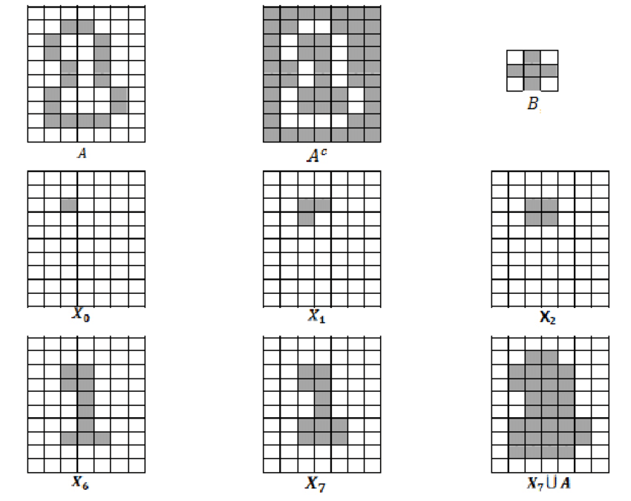

There is multiple ways to fill holes in image processing:

1. Areafill operations.
2. Morphological operations (like the example, dilation on the complemented image)
3. Floodfill operations.
4. Sometimes a combination of these methods along with image subtraction is used to identify the holes effectively.

(Somasundaram and Kalaiselvi 2010)

For more explanation see:

<https://www.youtube.com/watch?v=Vx3DiMaAebI>

*Masking*:” In some cases, it was useful to mask one organelle type with another. These masks could be inclusive (voxels outside the mask are set to background) or exclusive (voxels inside the mask are set to background). The masks could also be expanded by a set distance to increase the size of the mask. Masking proved especially useful when the optimal predictions for different classes came from different networks and iterations, meaning a single voxel could be assigned to multiple classes. “(Heinrich et al. n.d.)

**Masking:**

A mask is a binary image consisting of zero- and non-zero values. If a mask is applied to another binary or to a grayscale image of the same size, all pixels which are zero in the mask are set to zero in the output image. All others remain unchanged.

Source: <https://homepages.inf.ed.ac.uk/rbf/HIPR2/mask.htm>

Watershed and Agglomeration: “For over-merged organelles we employed the watershed-agglomeration segmentation methodology of Zlateski and Seung12 as implemented in waterz13. In this approach, watershed segmentation is performed on a smoothed version of the predictions, where all background voxels are set to 0. This resulted in overly segmented organelles. To reconstruct complete organelles, iterative agglomeration was performed based on the costs of merging adjacent segments. Here, two adjacent fragments were merged if a set percentage of their shared edge voxels had predicted distances greater than or equal to a set distance; the exact percentile and distance were chosen by an expert and varied from dataset to dataset. Using this agglomeration method, fragments were more likely to be merged if their shared edge was predicted to be deep within an organelle.

**Watershed-Agglomeration:**

First, I recommend watching again the video Nitsan once sent us, as understanding the Watershed algorithm depends on it :

[The distance transform](https://www.youtube.com/watch?v=oxWfLTQoC5A&t=4s)

And then :

Demonstration:

[Overview of the watershed algorithm](https://www.youtube.com/watch?v=WQpXS9gBEu8)

Watershed is one of the transformations on grayscale images that perform object segmentation.

In any grayscale images, there are areas where the intensity is high and there are some where intensity is low. We can denote these high intensity areas to peaks while low intensity areas to valleys. Think of an image as a topography map, where each pixel’s intensity contributes to the topography map, either a local elevation or a depression. To separate objects in images, we will fill out each valley with water of different colors. Slowly, the water will rise up and to a point water from different valleys start to merge. This is when we build barriers on top of the peak to avoid having the peak underwater. Once the barriers are built out, the barriers constitutes the boundary of the object.

Low intensity and high intensity can be determined according to distance transform after switching the picture to binary image and then thresholding it. (my interpretation)

Agglomeration means to merge over-segmented organelles with the same ID’s (from the watershed agglomeration).

Extra:

<https://homepages.inf.ed.ac.uk/rbf/HIPR2/threshld.htm#2> thresholding explanation.

Couldn’t find further information on:

Masked to Parent Organelle

Custom Reconstruction

Not even in the paper itself.